FULL SUBTRACTOR

AIM: To perform full subtractor using logicism

INPUT:

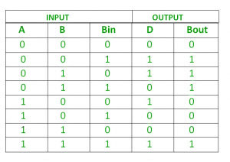

OUTPUT:

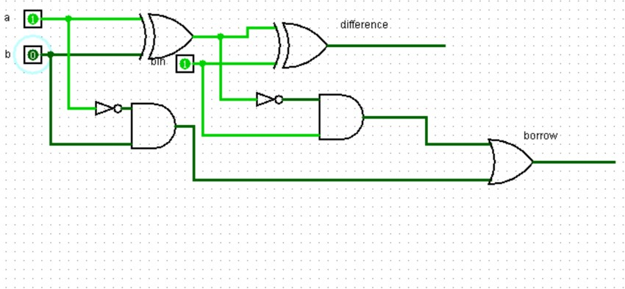

RESULT:

Thus full subtractor is executed successfully using logicism.